**DAILY ONLINE ACTIVITIES SUMMARY**

|  |  |  |  |  |  |  |  |  |
| --- | --- | --- | --- | --- | --- | --- | --- | --- |
| **Date:** | 03/06/2020 | | | | | **Name:** | CHANDANA S | |
| **Sem & Sec** | 4th SEM ‘A’ SEC | | | | | **USN:** | 4AL18CS016 | |
| **Online Test Summary** | | | | | | | | |
| **Subject** | | Object Oriented Concepts(18CS45) | | | | | | |
| **Max. Marks** | | 30 | | **Score** | | | 15 | |
| **Certification Course Summary** | | | | | | | | |
| **Course** | Introduction to Cyber security | | | | | | | |
| **Certificate Provider** | | | Great Learning | | **Duration** | | | 3.5 Hours |
| **Coding Challenges** | | | | | | | | |
| **Problem Statement:** 1. Write a C Program to find inversion count of array.  2. Write a Java program to find Perfect Sum Problem. | | | | | | | | |
| **Status:** Completed | | | | | | | | |
| **Uploaded the report in Github** | | | | | YES | | | |
| **If yes Repository name** | | | | | https://github.com/chandushivalingareddy/lockdown-coding | | | |
| **Uploaded the report in slack** | | | | | YES | | | |

**Online Test Details:**

The online test was from module 2 and 3 which was about the Introduction to Java, Classes, Inheritance, Exception Handling. There were 30 questions and the duration was 45 minutes. The questions were optimal and were easy. The score that I got in the test is 15/30.

**Snapshot:**

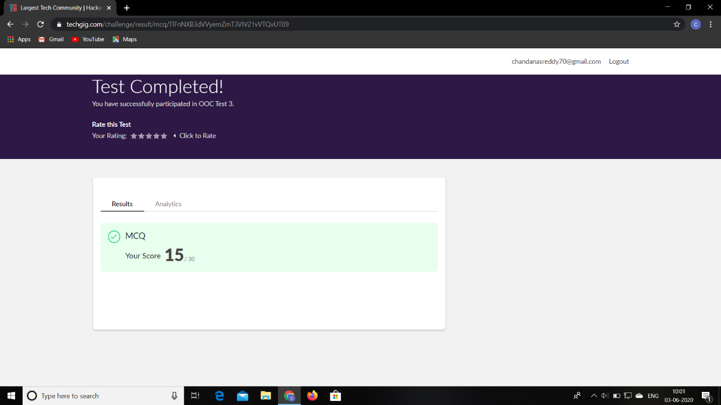

**Certification Course Details:**

**Name of the course**: Introduction to Cyber security

**Certificate Provider**: Great Learning

Today I went through the course that explained about Blockchain in Cyber security, Career and Industry Landscape, Governance and Risk, Introduction to Cryptography.

**Snapshot:**

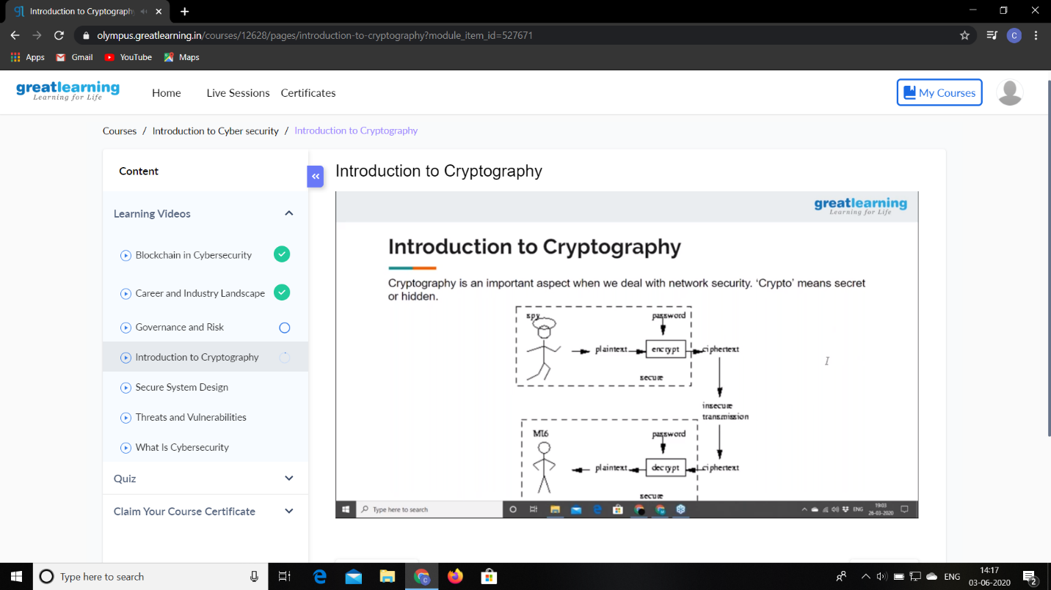

**Online Coding Details:**

Problem 1: Write a C Program to find inversion count of array.

**Snapshot:**

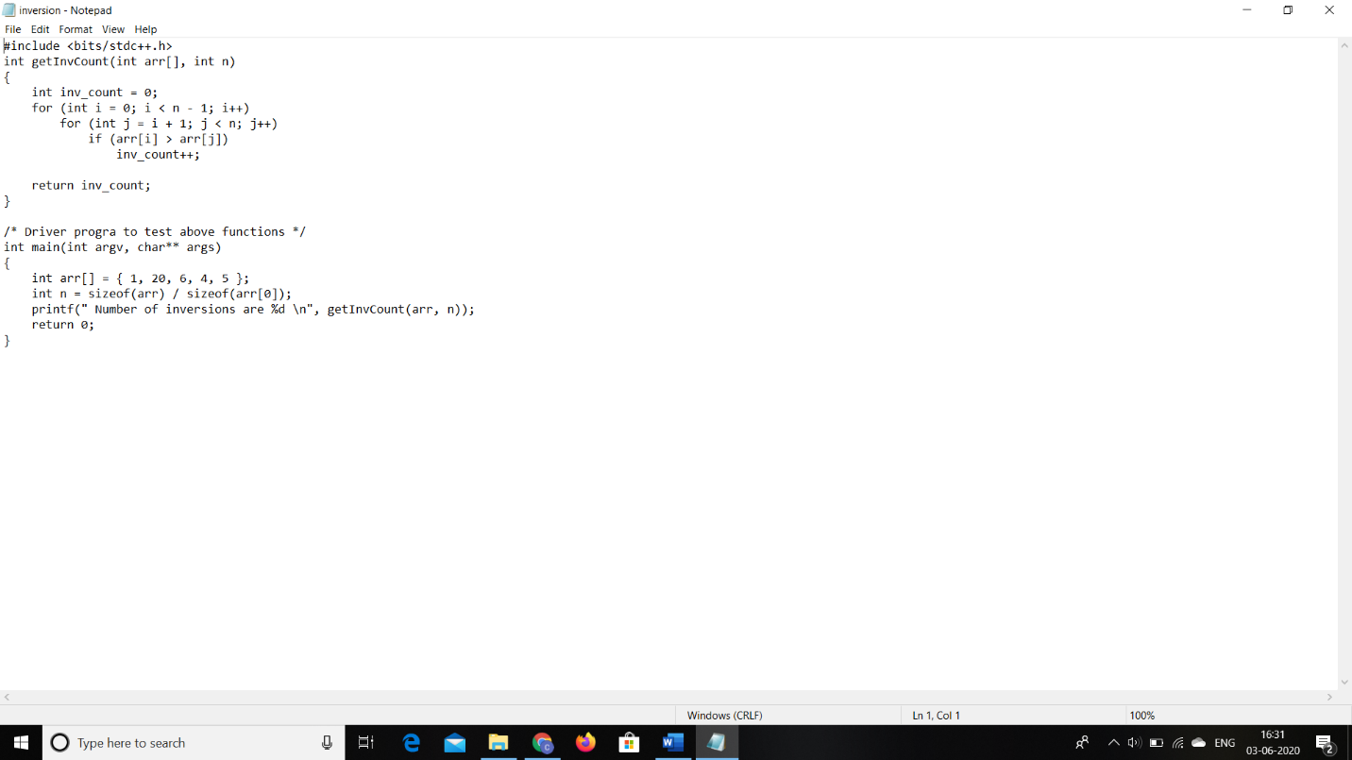

Problem 2: Write a Java program to find Perfect Sum Problem.

**Snapshot:**

